**PSG COLLEGE OF TECHNOLOGY**

**DEPARTMENT OF APPLIED MATHEMATICS AND COMPUTATIONAL SCIENCES**

**IV SEM – M.SC SOFTWARE SYSTEMS – WORKSHEET – SYSTEM CALLS**

1. Implement the following command using appropriate system calls that outputs the number of occurrences of the string ‘hai’ (case in-sensitive) stored in a file ‘file1’.

cat file | grep –i hai | wc

Create two pipes Pipe0 and Pipe1 as shown in the following figure.

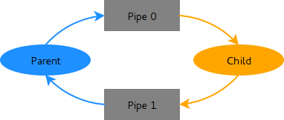

Pipe0 and Pipe1 are used to transmit data from parent to child and child to parent respectively. Parent process stores the contents of the file ‘file1’ into Pipe0 and waits for child to complete. The child process uses that as input for grep command and stores the output of grep into Pipe1 and it terminates. The parent process obtains data from Pipe1 and displays the word count.

Note: Parent uses read() to read from a file and write() to write into pipe for cat file.